**FitFlex: Your Personal Fitness**

**Companion(React Application)**

|  |  |
| --- | --- |
| Team ID | SWTID1741146831 |

|  |  |  |
| --- | --- | --- |
| Team Leader | AKSHAYA D | akshaya.d12a@gmail.com |
| Team Member 1 | GAYATHRI DEVI G | gayu30122004@gmail.com |
| Team Member 2 | MADHUMITHA P | madhu23perumal@gmail.com |
| Team Member 3 | NIRANCHANA G | gniranchana1@gmail.com |
| Team Member 4 | OVIYA J M | oviyajayakumar7271@gmail.com |

**1. Introduction:**

**FitFlex** is an all-in-one fitness app designed for users of all levels, offering a user-friendly experience with a wide range of exercises, personalized workout plans, and progress tracking. With smart search filters, goal-based recommendations, and a built-in community for sharing achievements and joining challenges, FitFlex helps users stay motivated and committed to their fitness journey.

**2. Project Overview:**

* **Purpose:** FitFlexis designed to enhance the workout experience by offering an intuitive interface, personalized fitness plans, and dynamic search functionalities. The app aims to support users in their fitness journey through a seamless and interactive platform*.*
* **Features:**
  + Real-Time Exercise Search: Integrated with a Fitness API, allowing users to search for exercises with real-time updates.
  + Visual Exercise Exploration: High-quality images and tutorial videos for each exercise help users perform workouts correctly.
  + User-Friendly Design: Clean and responsive interface ensures smooth navigation across various devices.
  + Advanced Search Filters:  
    Users can filter exercises by:
* Muscle groups
* Difficulty level
* Equipment type

**3. Technical Architecture:**

* **Frontend:** React.js, React Router, Axios, Tailwind CSS/Bootstrap.
* **Backend:** APIs integrated via Rapid API for fitness data.
* **Database:** Firebase for user authentication and workout data storage.
* **Version Control:** GitHub for collaboration and code management.
* **Development Environment:** Visual Studio Code, Node.js, and npm for dependency management.
* **Hosting & Deployment:** Netlify or Vercel for frontend hosting, Firebase for backend services.

**4. Setup Instructions:**

* **Prerequisites:**

To set up the FitFlex project, the following tools are required:

* **Node.js & npm:** Install from [Node.js official site](https://nodejs.org/).
* **React.js Framework:** Install using npx create-react-app fitflex-app.
* **Git Version Control:** Install from [Git official site](https://git-scm.com/downloads).
* **Code Editor:** Visual Studio Code or WebStorm.
* **API Key:** Obtain a Rapid API key for fetching fitness data.
* **Firebase Setup:** Set up a Firebase project for user authentication and real-time data storage. To set up the FitFlex project, the following tools are required:
* **Installation:**
  + **Clone repository:**
  + git clone [repository-link]

cd fitness-app-react

* + **Install dependencies:**

npm install

* + **Run the application:**

npm start

* + Open http://localhost:3000/ in your browser.

**5. Folder Structure:**

* **Components Folder:** Stores reusable UI components such as buttons, modals, and cards.
* **Pages Folder:** Contains different pages of the application like Home, Categories, and Exercise Details.
* **Styles Folder:** Holds CSS stylesheets for styling components.
* **Services Folder:** Contains API service files for managing API calls.
* **Context Folder:** Manages global state using React Context API.
* **Utils Folder:** Includes helper functions for common utilities.

**6. Running the Application :**

* **Command to start frontend server:**
* npm start
* Runs on <http://localhost:3000>

**7. Component Documentation:**

* **Key Components:**
  + Navbar.js - Navigation menu.
  + Search.js - Handles user searches.
  + Category.js - Displays workout categories.
  + ExerciseDetail.js - Displays individual exercise details.
* **Reusable Components:**
  + Button.js - Custom button component.
  + Card.js - Displays exercise cards.

**8. State Management:**

* Global State: Managed via React Context API, ensuring shared state across components efficiently.
* Local State: Managed using useState and useEffect hooks for component-specific data handling and side effects.

**9. User Interface:**

* Includes responsive design with interactive elements, ensuring a seamless user experience across different devices.
* Features include workout galleries, real-time search, and exercise detail pages.

**10. Styling:**

* **CSS Frameworks/Libraries:**
  + Tailwind CSS for styling.
  + React Icons for icons.
* **Theming:**
  + Light/dark mode toggle available.
  + Custom themes implemented using CSS variables and Tailwind configurations.

**11. Testing :**

* Test UI responsiveness across multiple devices.
* Debug API requests and responses using Postman.
* Validate Firebase authentication and database transactions.

Screenshots of the application, including the Hero section, category page, and exercise page, can be found in the project repository. After development, run the project using:

npm start

Screenshots of the application, including the Hero section, category page, and exercise page, can be found in the project repository.

**12. Screenshots or Demo:**

* Screenshots of the homepage, search results, and exercise details.

**Home page:**

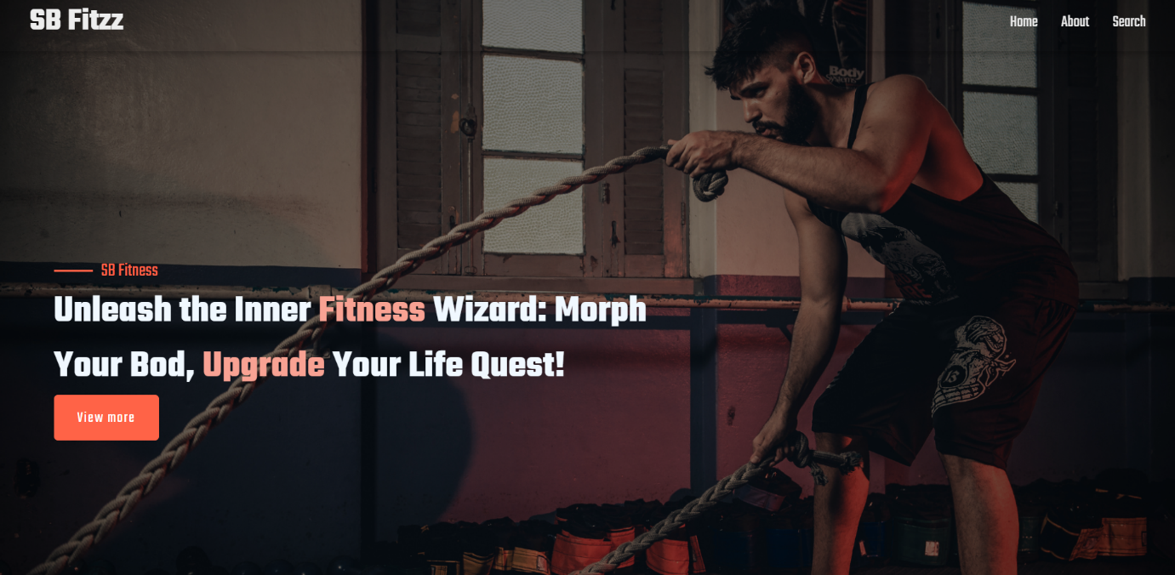

**About page:**

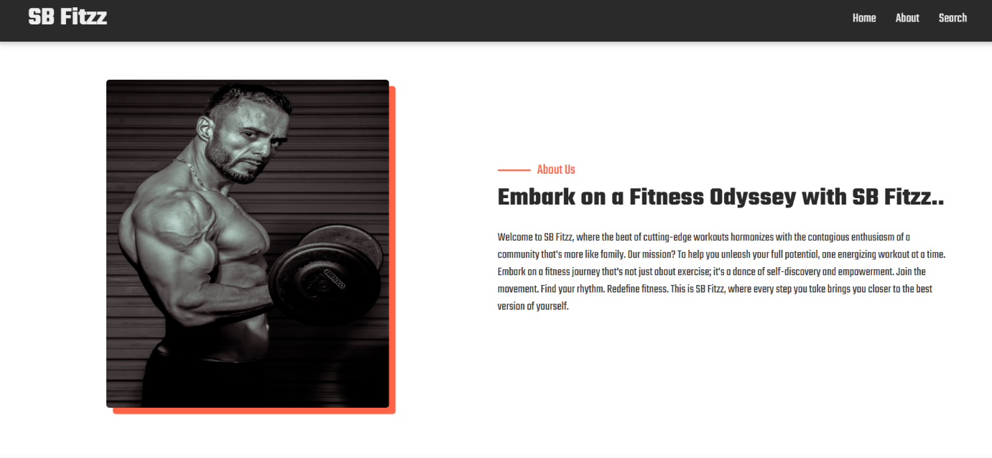

**Search page:**

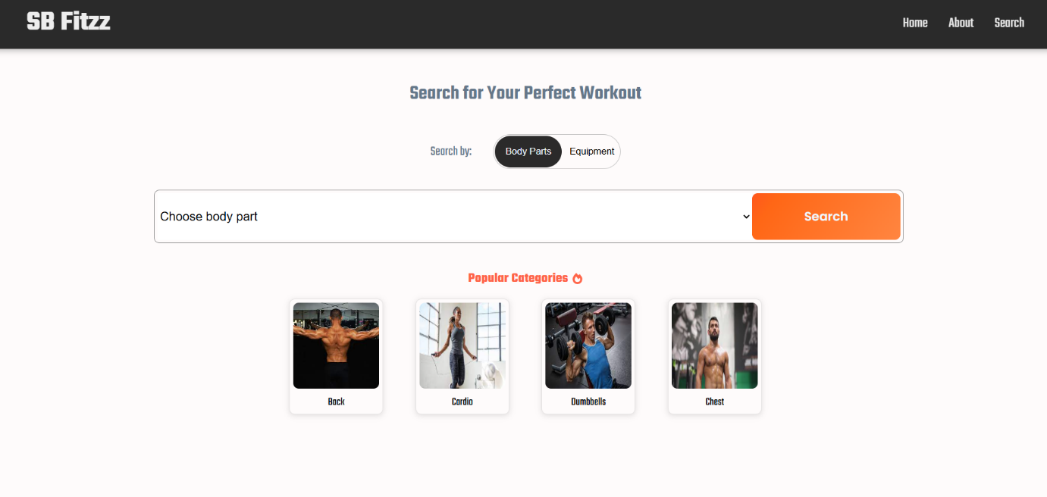

**Search result page:**

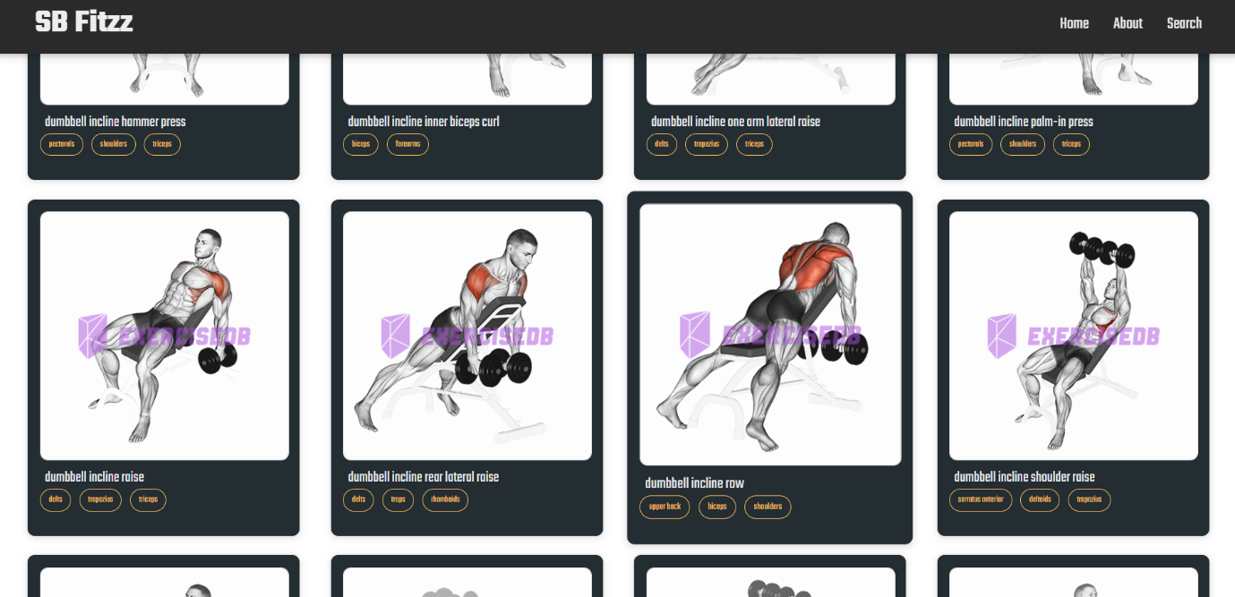

**Demo Link:**

[**https://drive.google.com/file/d/1jaKwsRvjRBMfSDz4EdTfepziCU0cuHy3/view?usp=drive_link**](https://drive.google.com/file/d/1jaKwsRvjRBMfSDz4EdTfepziCU0cuHy3/view?usp=drive_link)

**13. Known Issues:**

* API rate limits may affect search performance, potentially leading to temporary unavailability of certain exercises.

**14. Future Enhancements :**

* **Nutrition Tracking**– Add a feature to track what you eat and how many calories you take in.
* **Smart Workout Suggestions** – The app can suggest exercises based on your fitness level and progress.
* **Connect with Smartwatches** – Link with devices like Fitbit or Apple Watch to track steps, heart rate, etc.
* **Gamification** – Add badges, streaks, and leader boards to boost motivation.
* **Live Sessions** – Enable live workouts with trainers or fitness groups.
* **Offline Mode** – Access saved workouts without internet.
* **Mental Wellness** – Include meditation and breathing exercises.
* **Community Features** – Groups, challenges, and social sharing for better engagement.